CLONING CONCEPT
Assignment 1: Base Table Analysis
- Load both datasets into Snowflake tables
Employee Table
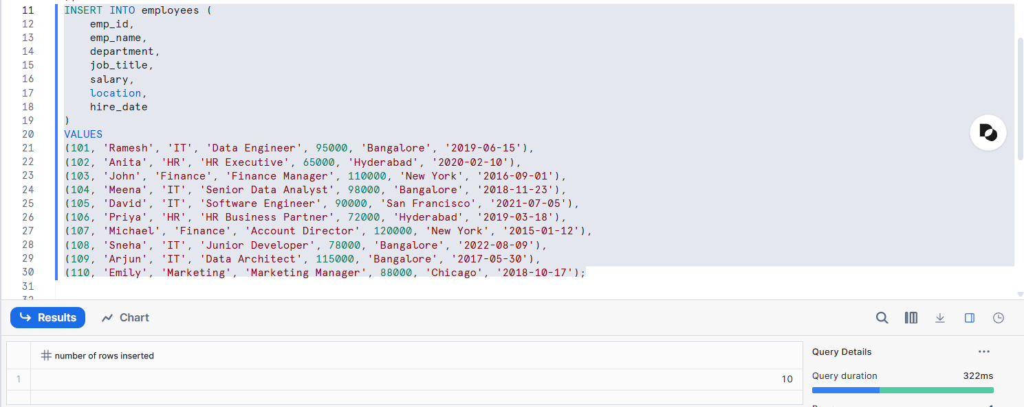
Department Tables
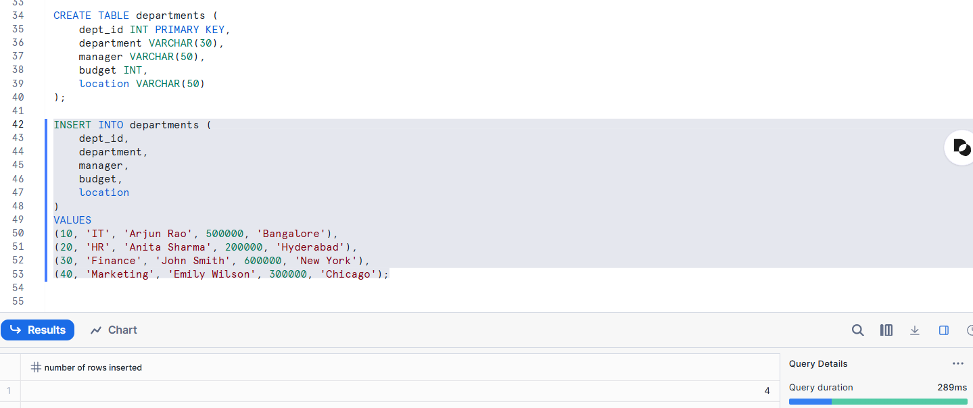
- Validate row counts and data distribution
Confirms that all expected records are loaded.
Validate rows for employees
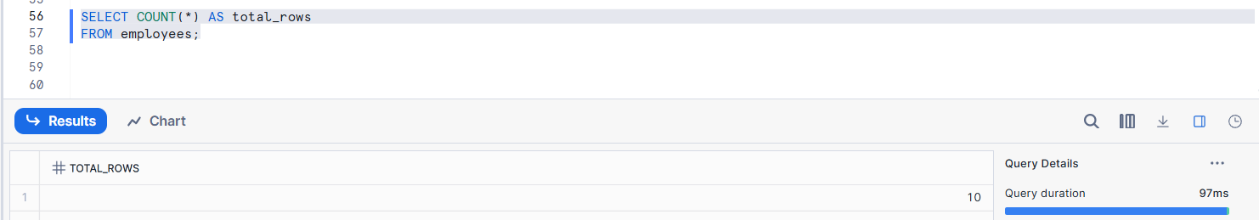
Validate rows for departments
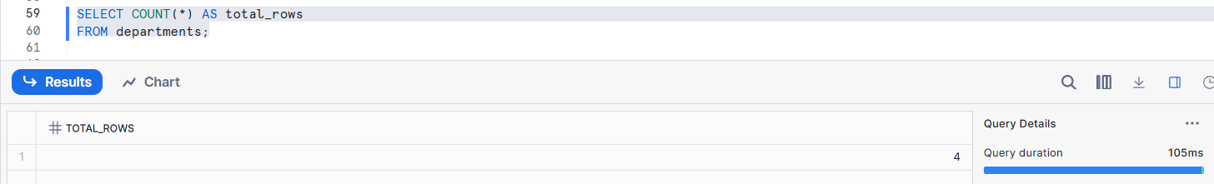
Data Distribution for Employees
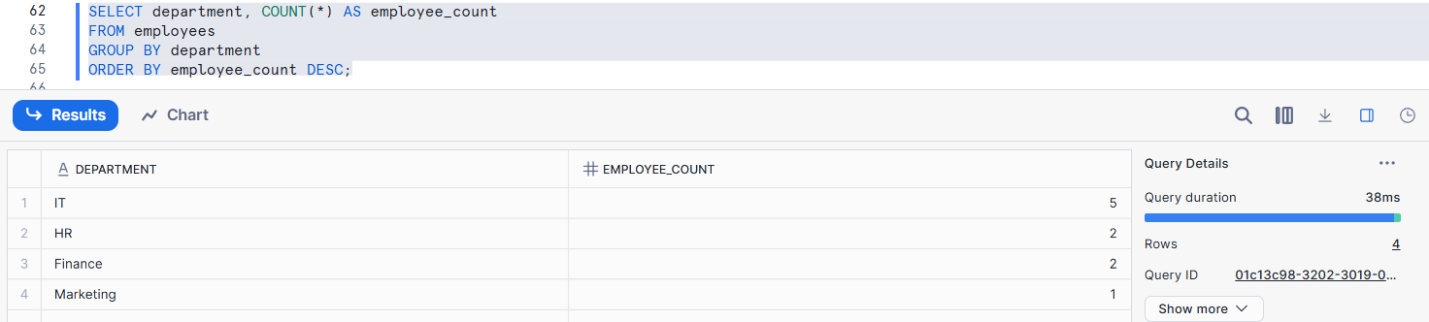
Data Distribution for Departments
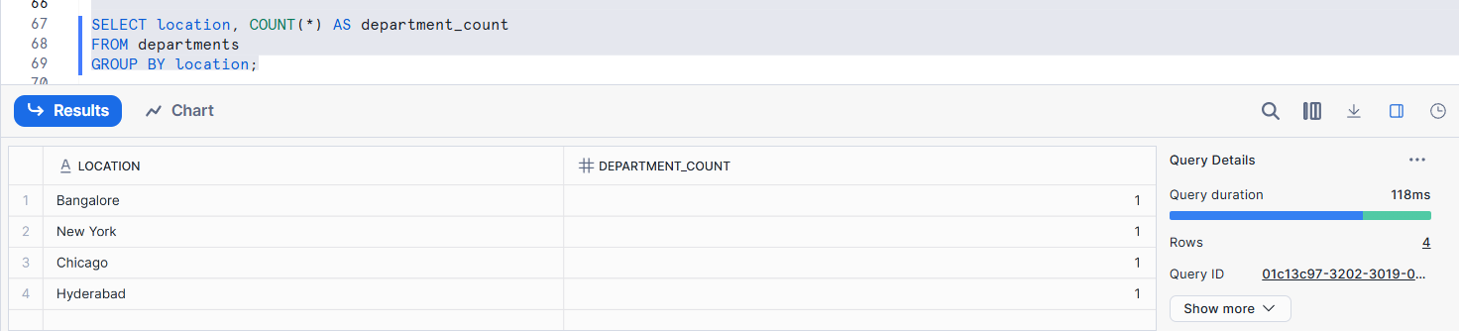
- Identify candidate tables for cloning
Candidate tables for cloning are large, frequently used tables that need to be copied for testing or analysis without affecting production data.
- Explain why these tables are suitable for cloning experiments
The suitability of selected tables for cloning experiments based on data size, structure, and testing requirements.

Assignment 2: Table-Level Cloning
- Clone the employee table
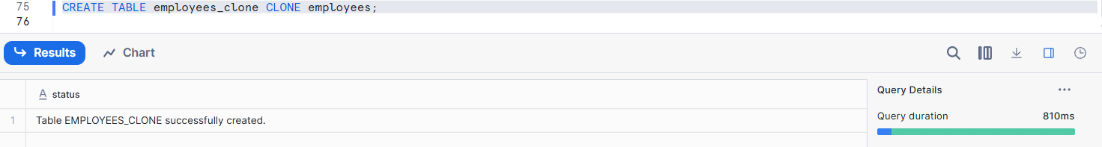
- Compare:
  - Row count
Ensures data consistency between original and clone.
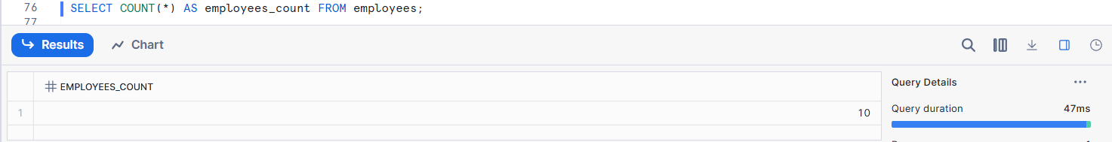
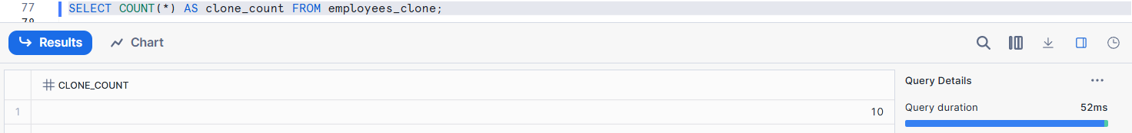
  - Query performance
Compare execution time for the same query on both tables.
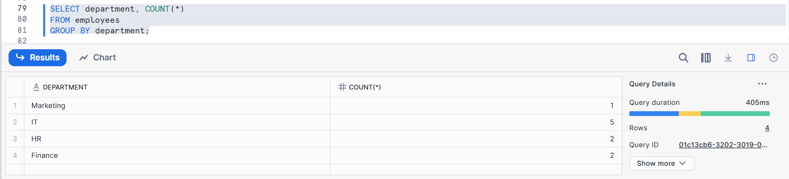
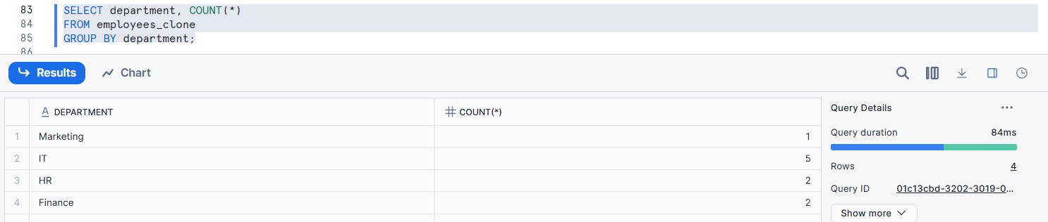
  - Storage usage
Check how much physical storage each table consumes.
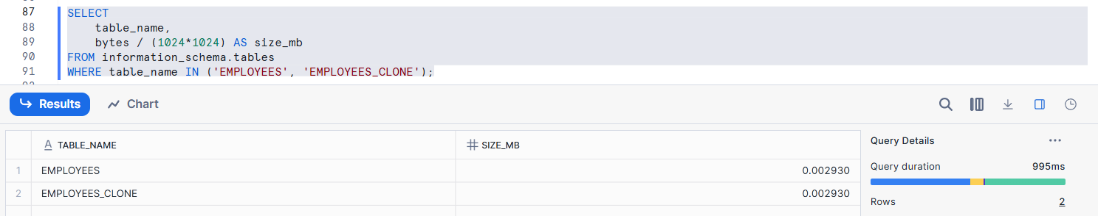
- Explain why clone creation is instantaneous
Clone creation in Snowflake is instantaneous because it uses a zero-copy cloning architecture.
When a clone is created, Snowflake does not physically duplicate the data. Instead, it creates a new table that references the same underlying micro-partitions as the source table. Only metadata pointers are copied, which is a lightweight and fast operation.

Assignment 3: Change Isolation Testing
- Update salary data in the original employee table
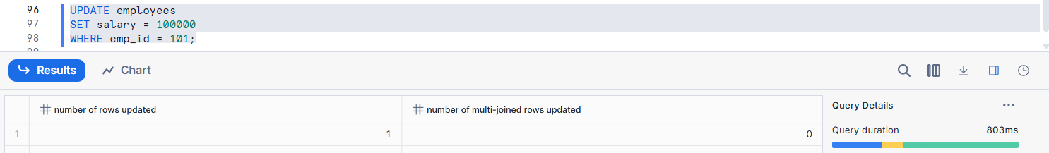
- Delete records in the cloned table
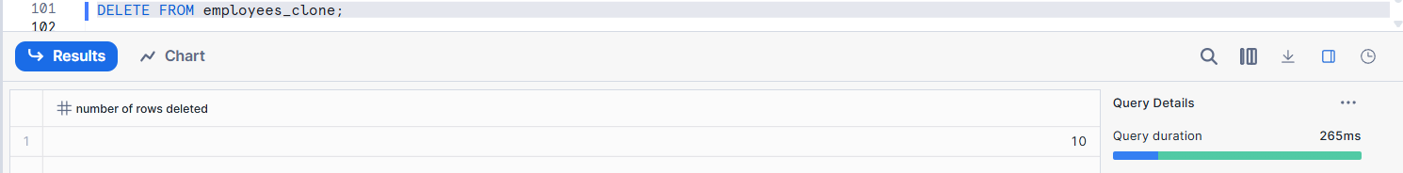
- Insert new records in the clone
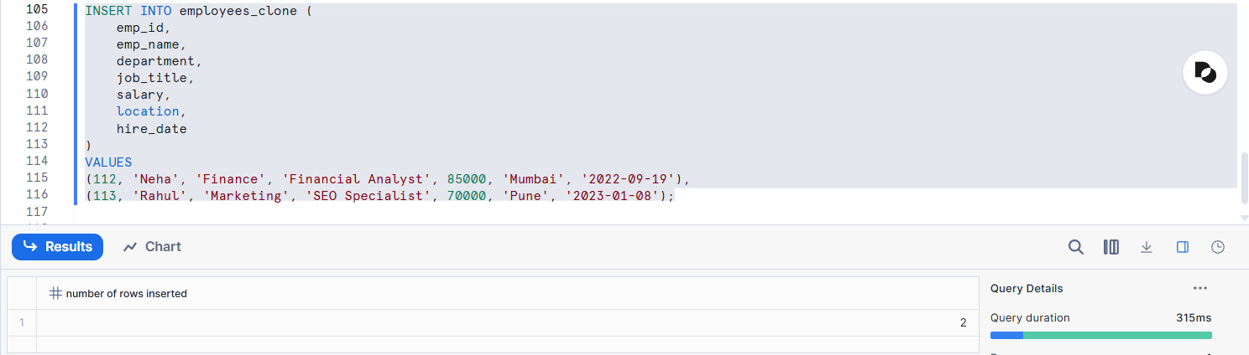
- Validate isolation between original and clone
Original
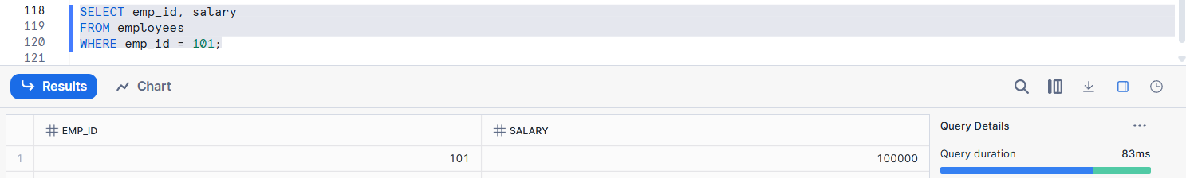
Clone
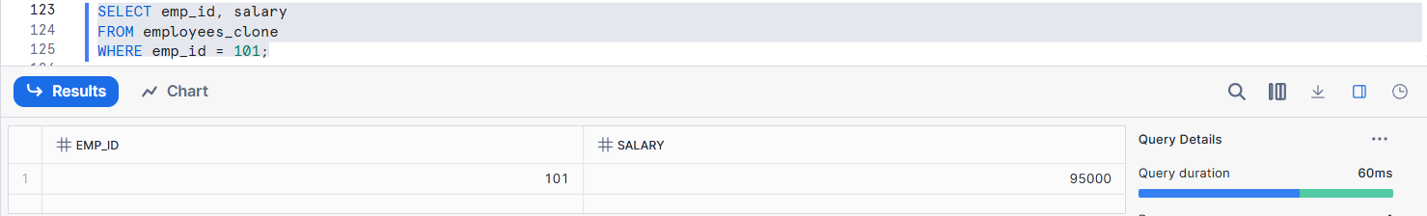
- Explain backend copy-on-write behavior
When a table is cloned, the original and the clone initially share the same micro-partitions in storage. No physical data is copied at this stage; only metadata references are shared.
When a DML operation (INSERT, UPDATE, DELETE) is performed on either the original table or the clone, Snowflake does not modify the shared micro-partitions. Instead, it creates new micro-partitions that contain only the changed data. The table being modified is then updated to point to these new partitions, while the other table continues to reference the original ones.

Assignment 4: Storage Growth Exploration
- Perform DML operations incrementally
INSERT
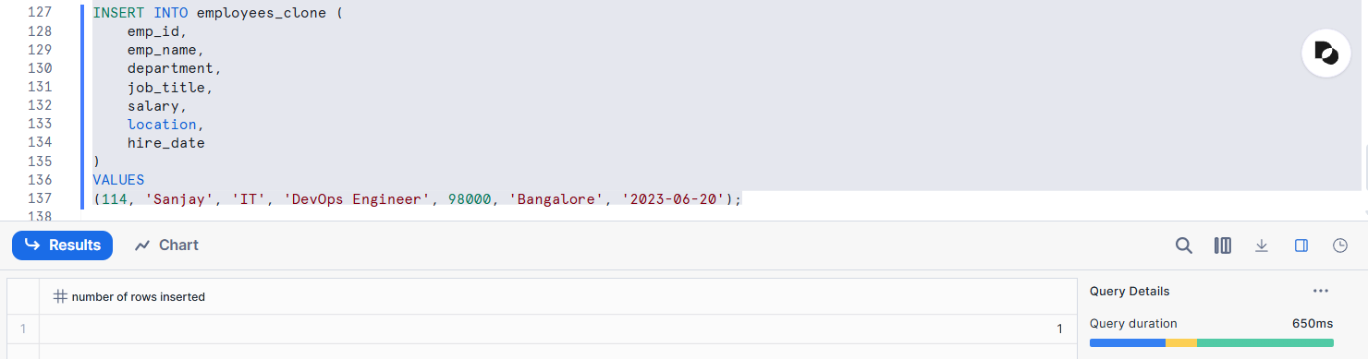
UPDATE
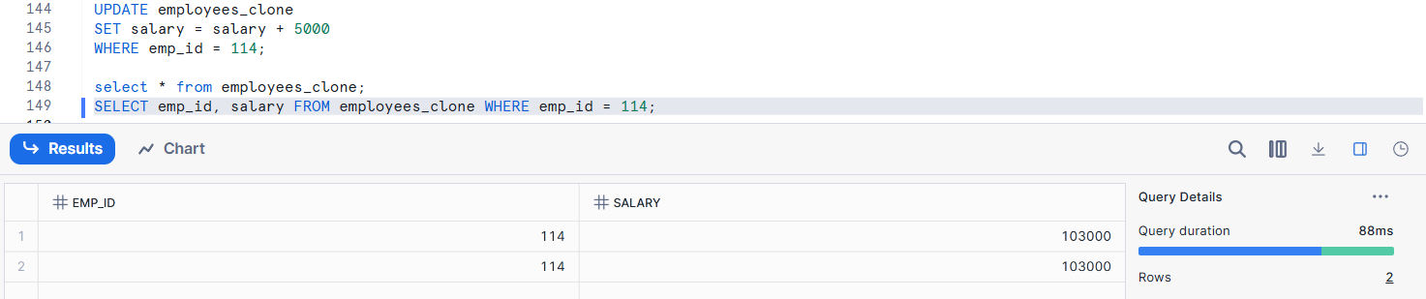
DELETE
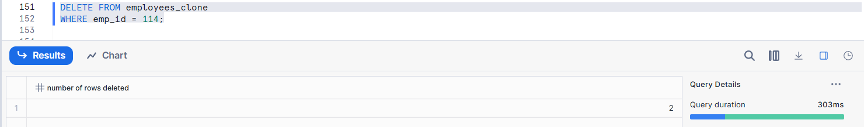
- Track storage before and after each operation
BEFORE INSERT
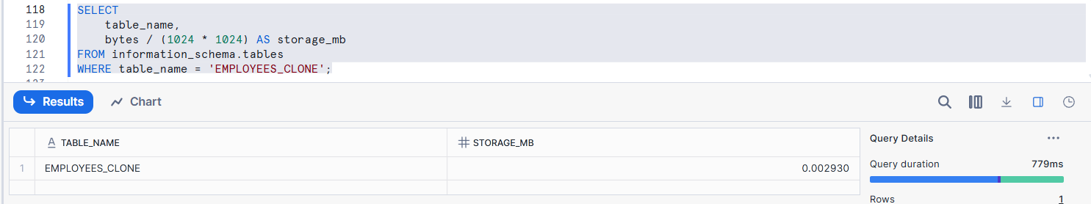
AFTER INSERT
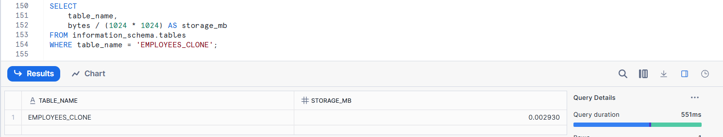
AFTER UPDATE
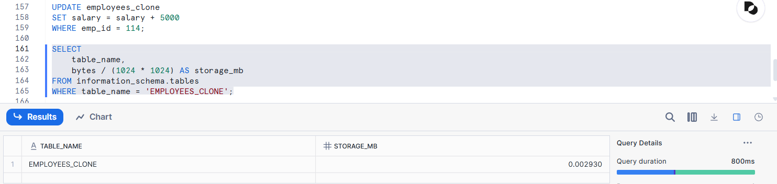
AFTER DELETE
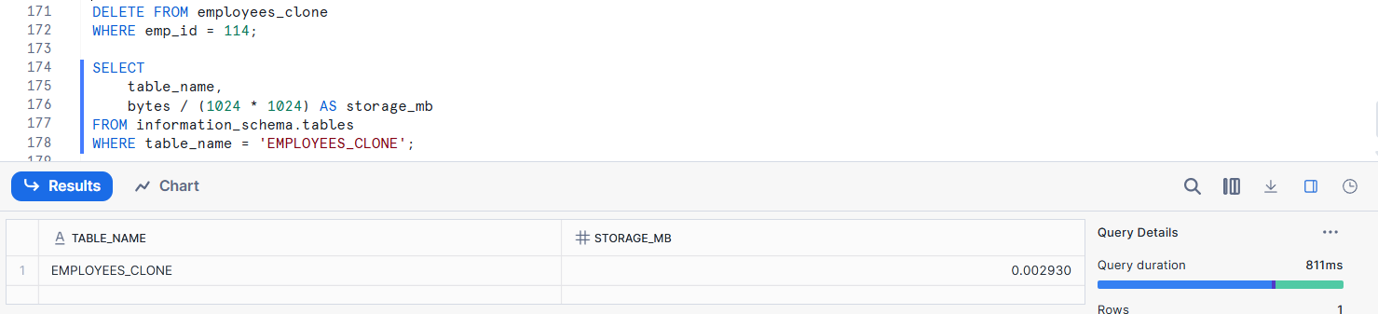
- Identify the exact moment storage increases
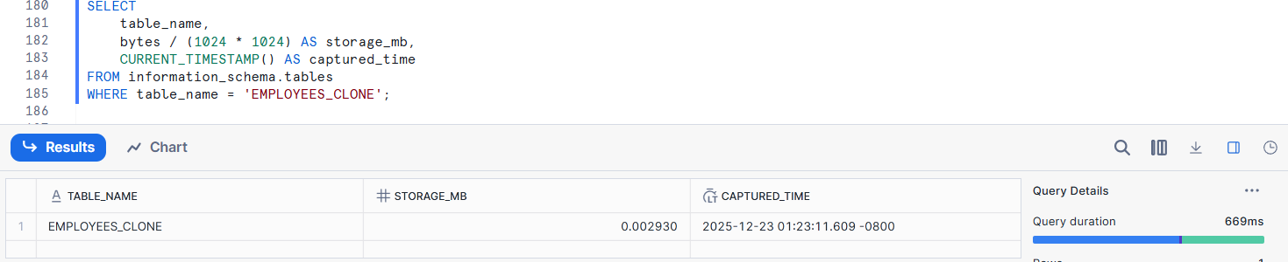
AFTER STORAGE
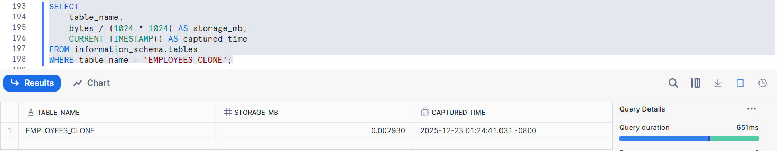
- Explain Snowflake’s physical storage strategy
Snowflake’s physical storage strategy is based on a decoupled, columnar, and immutable storage architecture designed for scalability, performance, and cost efficiency.
Data is stored in Snowflake-managed cloud object storage (such as Amazon S3, Azure Blob Storage, or Google Cloud Storage) in a compressed, columnar format.
Instead of modifying existing data, Snowflake creates new micro-partitions when DML operations occur and uses metadata pointers to track which partitions are active. This enables features such as Time Travel, zero-copy cloning, and fail-safe, while maintaining high read performance.

Assignment 5: Time Travel Cloning
- Perform multiple updates on the original table
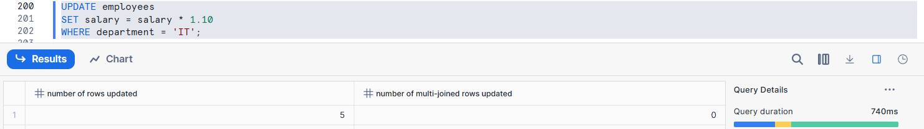
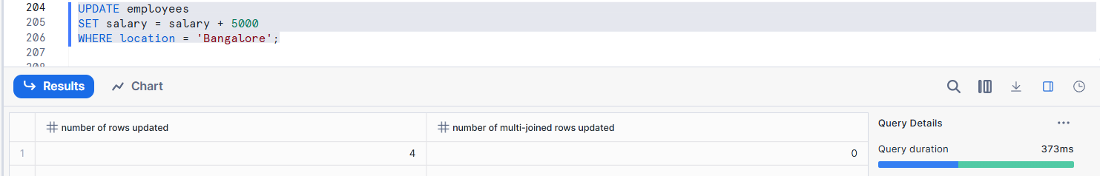
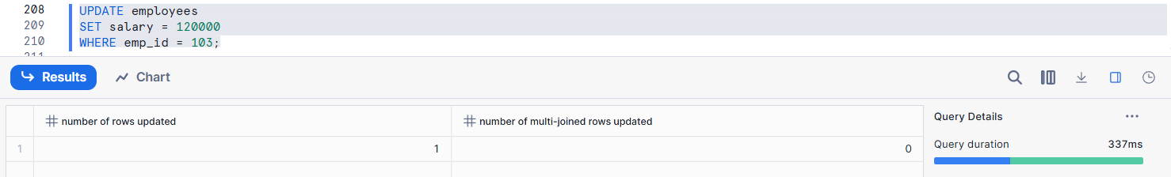
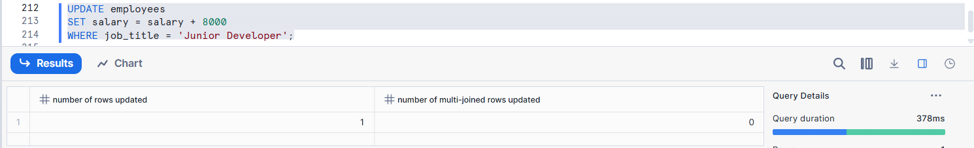
Validation
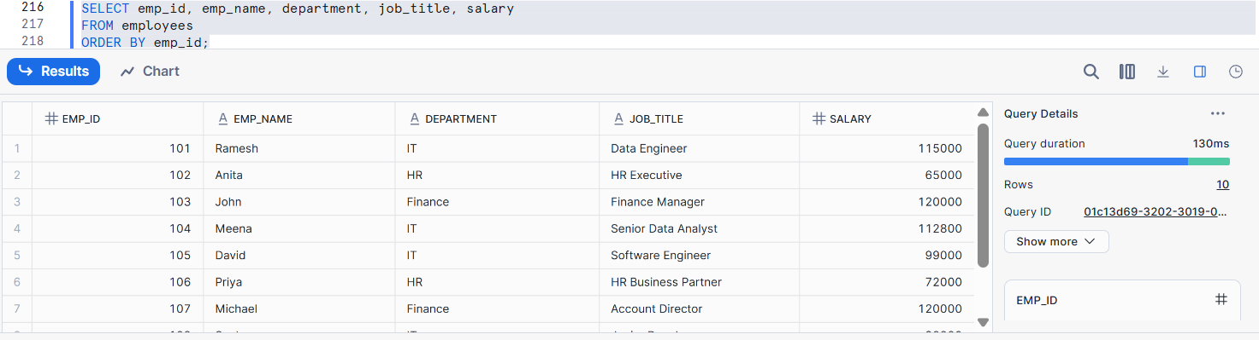
- Create clones from:
  - Current state
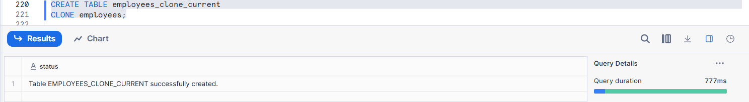
  - Past state (Time Travel)
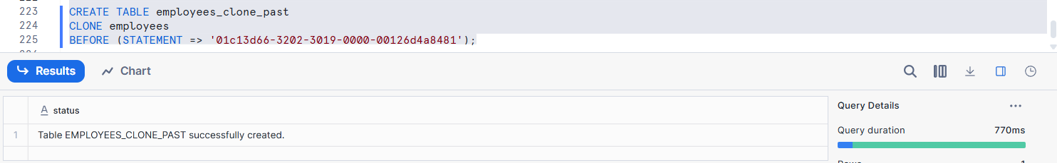
- Compare data across versions
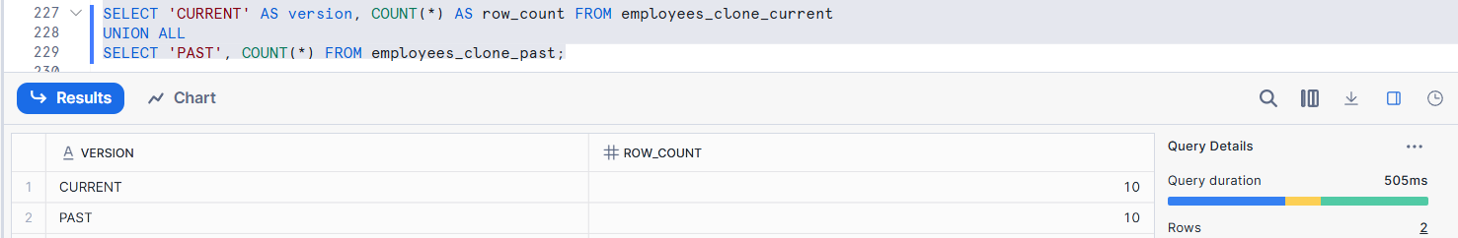
- Explain real-world recovery use cases
In Snowflake, real-world recovery use cases are enabled primarily through Time Travel, Fail-safe, and Zero-Copy Cloning.
Accidental Data Deletion - Use Time Travel to restore the table to a point before deletion.

Assignment 6: Schema-Level Cloning
- Clone a schema containing employee and department tables
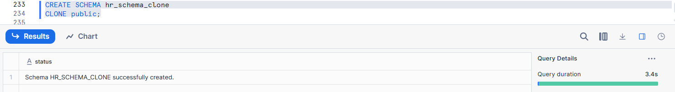
- Modify tables in cloned schema
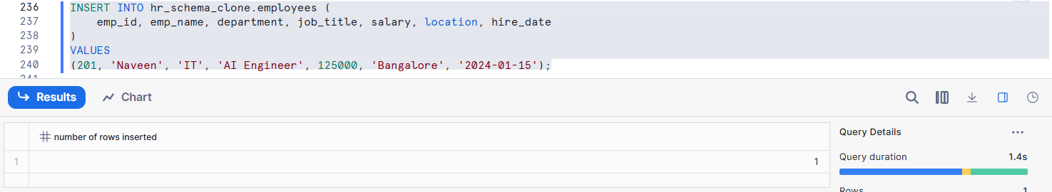
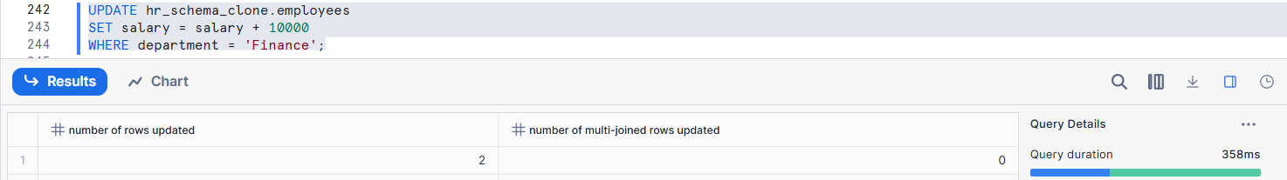
- Drop tables in original schema
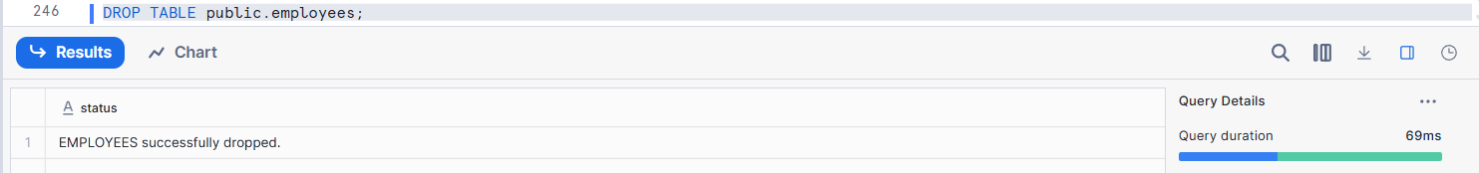
- Observe behavior and explain metadata inheritance
In Snowflake, metadata inheritance describes how object definitions, properties, and access controls are propagated or shared—especially during operations like cloning, role grants, and object creation. Observing this behavior is essential to understand how Snowflake achieves consistency, security, and efficiency.

Assignment 7: Database-Level Cloning
- Clone the entire database
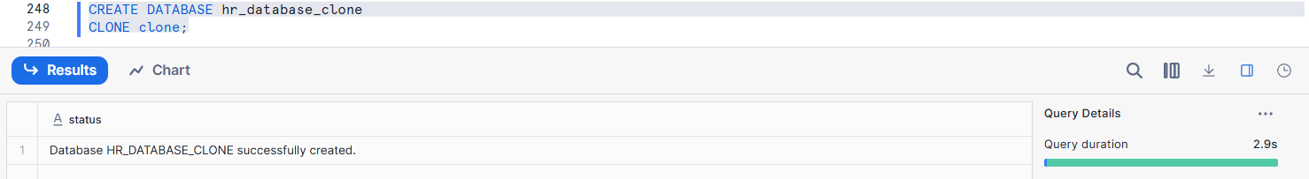
- Test query access and object availability
Test Query Access
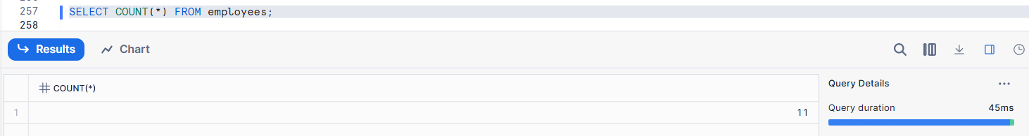
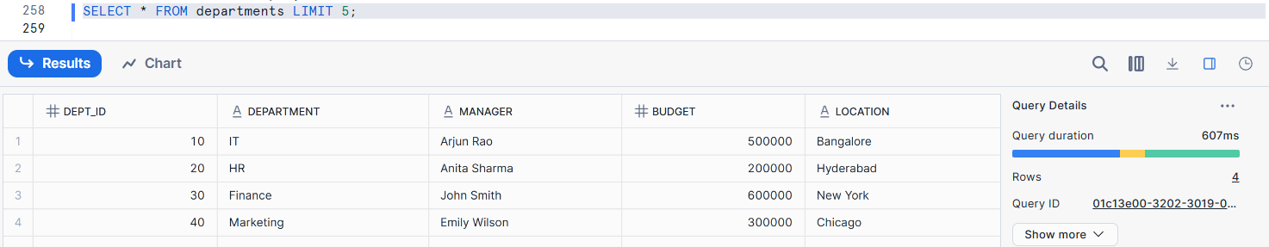
Object Availability
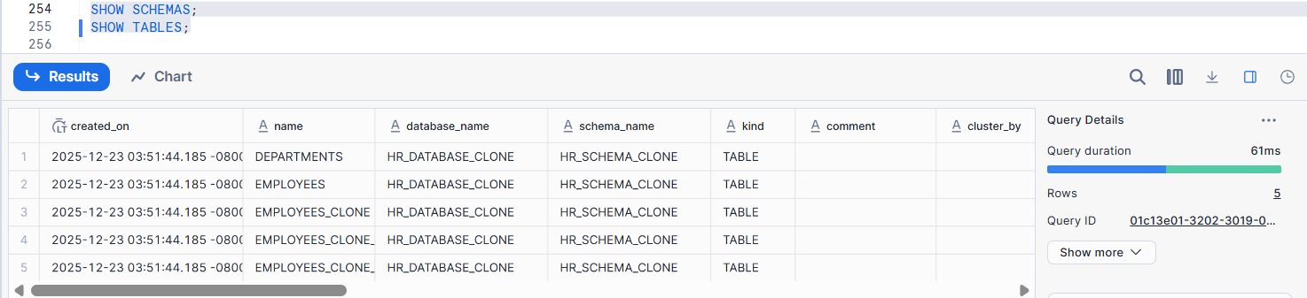
Checks column availability
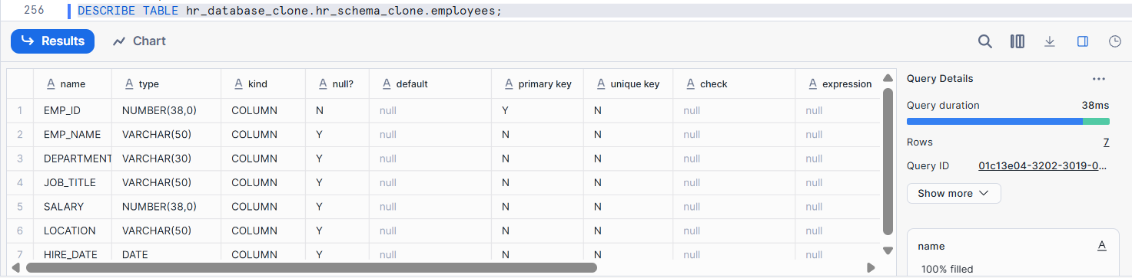
- Perform DML on cloned database
INSERT
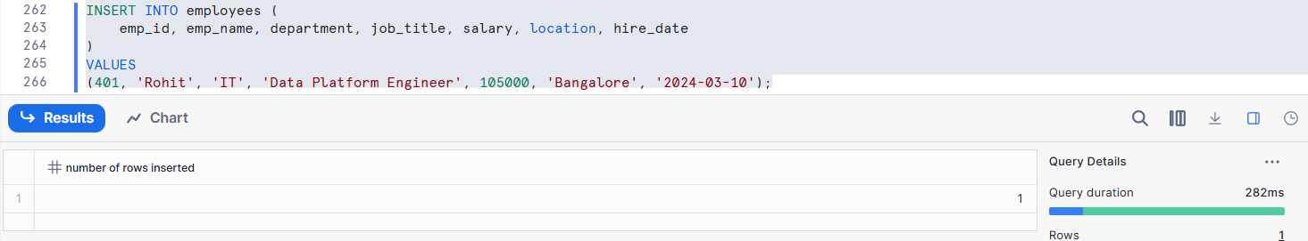
UPDATE
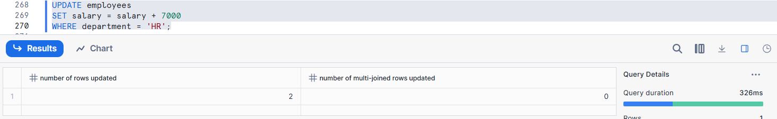
DELETE
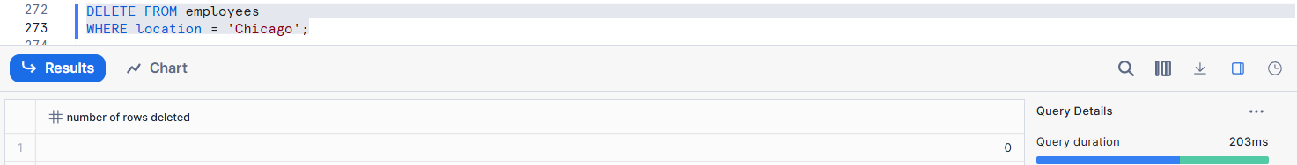
- Explain how Snowflake isolates environments (Dev/Test/Prod)
Snowflake isolates Dev, Test, and Prod environments through a combination of logical separation, role-based security, compute isolation, and controlled data movement, rather than physical infrastructure separation.

Assignment 8: Privileges & Security
- Analyze access privileges before cloning
DATABASE
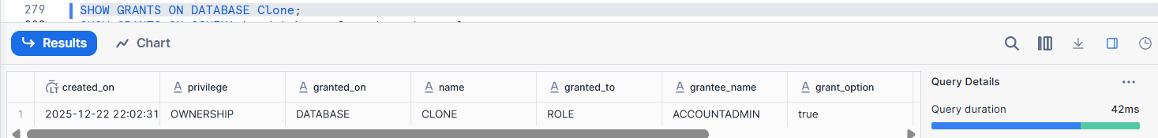
SCHEMA
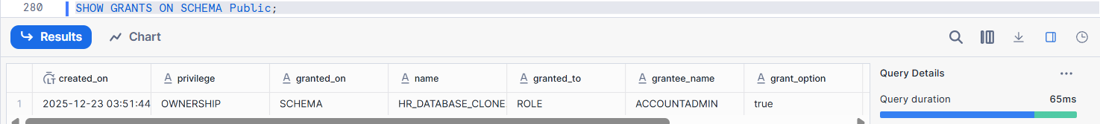
TABLES
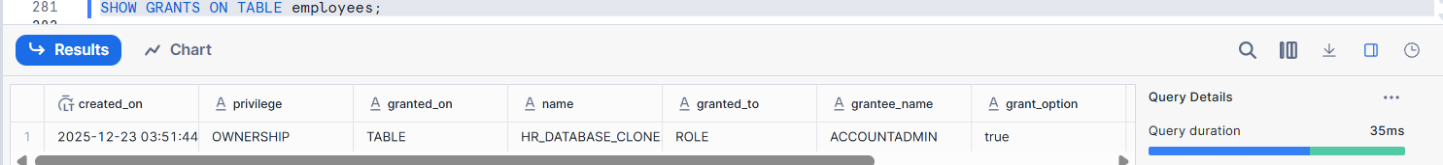
- Observe privileges after cloning
After cloning, privileges are NOT copied automatically.
DATABASE
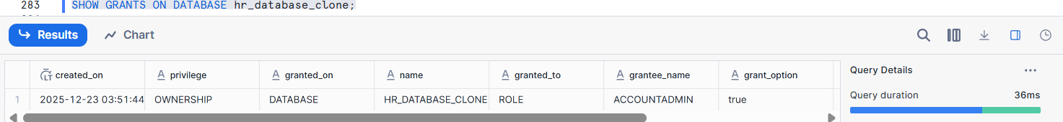
SCHEMA
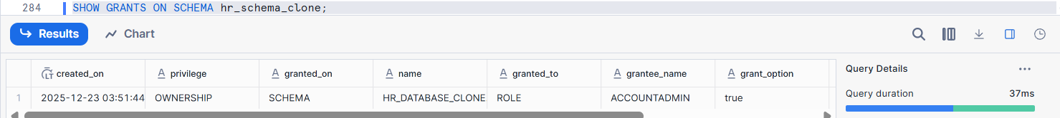
TABLE
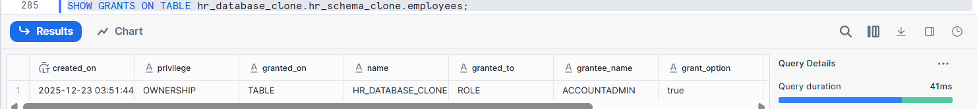
- Modify privileges on clone
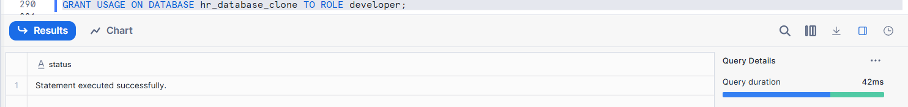
- Explain why Snowflake handles security this way
Snowflake handles security using a privilege-based model because it is designed to support strong data governance, scalability, and fine-grained access control in a cloud-native, multi-tenant environment.

Assignment 9: Performance Comparison
- Run identical analytical queries on:
  - Original tables
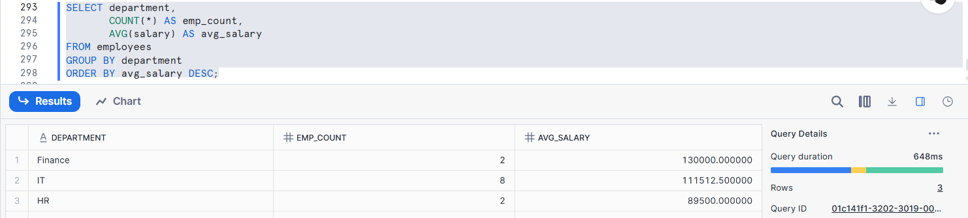
  - Cloned tables
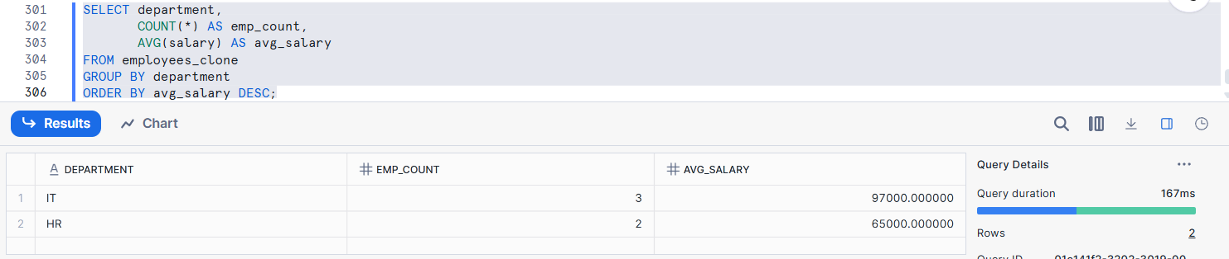
- Compare execution plans
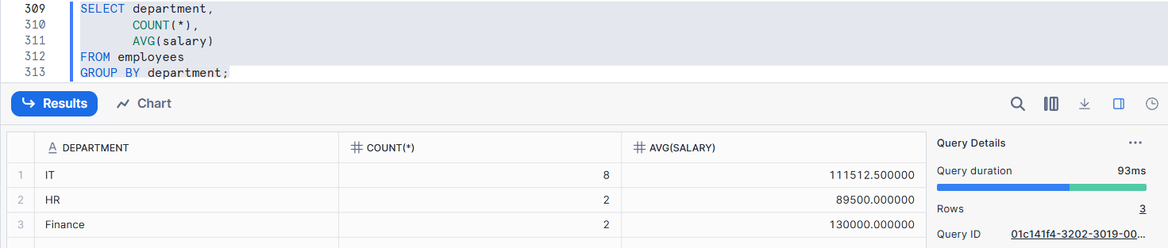
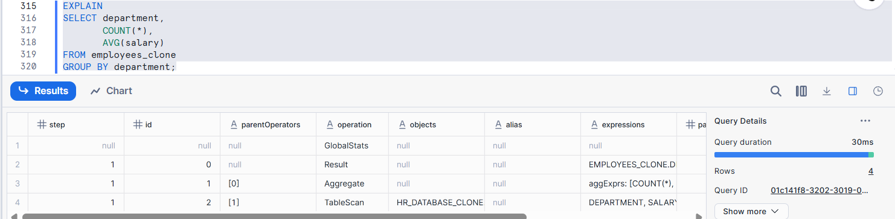
- Explain performance similarities/differences
Original and cloned tables show similar performance because Snowflake cloning shares the same physical data; any minor differences are due to caching or workload, not data duplication.

Assignment 10: Cleanup & Retention
- Drop original objects
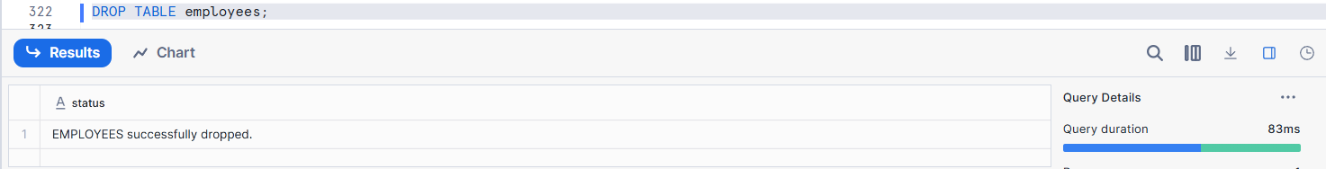
- Validate cloned object availability
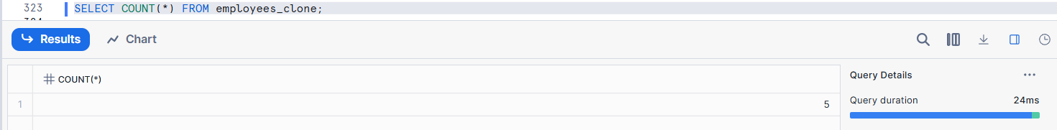
- Drop clone and analyze Time Travel behavior
Drop Table
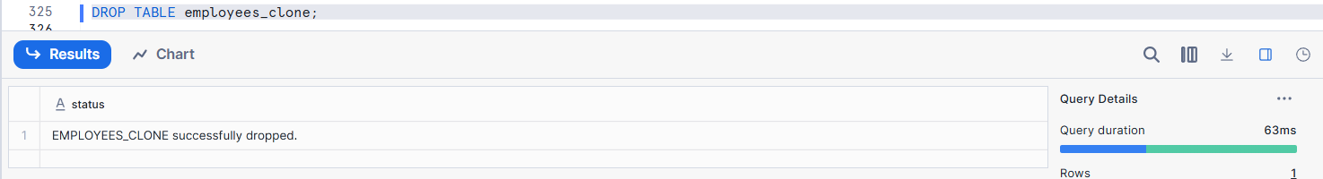
Time Travel
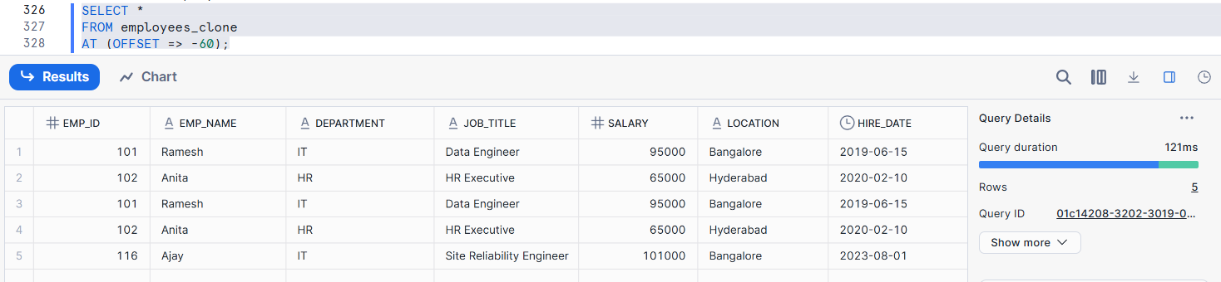
- Explain lifecycle and retention rules
After an object is dropped, Snowflake keeps it in Time Travel for recovery, then in Fail-safe, and finally deletes it permanently.

